ASSIGNMENT 4: UML DIAGRAM

1. USE CASES

Use Case: Login

* Logs in a user and gives them access to their personal info and associated permissions

Use Case: Create Account

* Allows a user to become a member by inputting their information (Use Case: Edit Personal Info) and logging in (Use Case: Login)

Use Case: Edit Personal Info

* Allows a member or higher to edit their own personal information after logging in (Use Case: Login)

Use Case: Manage Post

* Allows a member or higher to create/edit/delete their own post provided there are no replies.

Use Case: Create Thread

* Allows a member or higher to create their own thread which is a collection of posts

Use Case: Manage a thread

* Allows a Moderator or higher to move/close/delete (Use Case: Manage Post) a thread of their choice.

Use Case: Delete Post

* Allows a Moderator or higher to delete a post which has replies (Use Case: Manage Post).

Use Case: Ban User

* Allows a Moderator or higher to ban a user from the website until they are unbanned.

Use Case: Manage User

* Allows an Admin to change/delete a user.

Use Case: Manage Forum

* Allows an Admin to create/edit/delete an entire forum (Use Case: Manage Thread).

Use Case: Classify

* The AI looks at a an individual post and gives it a generalized classification of either positive, negative, or neutral.

Use Case: Detect Offensive

* The AI will look at an entire thread and count the number of negative posts (Use Case: Classify) and then alerts a moderator or administrator.

Use Case: Detect Toxic

* The AI will re-evaluate a thread and if the number of negative posts (Use Case: Detect Offensive) is above a certain percentage then the thread is classified as toxic and Mods and Admins are alerted.

2. Use Case Diagram

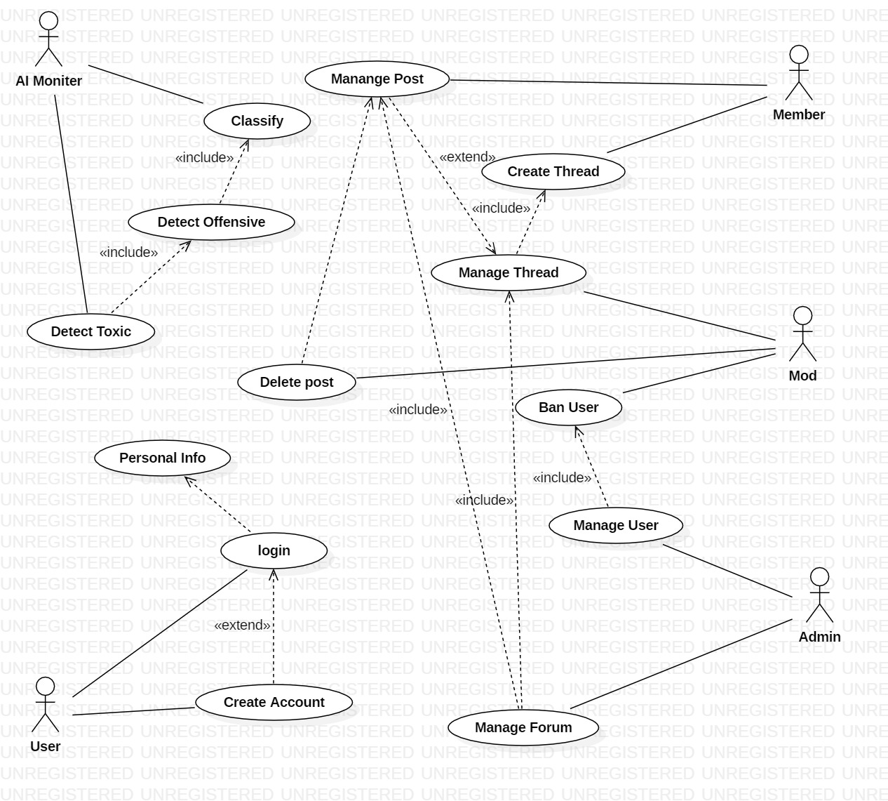

3. CRC CARDS

|  |  |
| --- | --- |
| **USER** | |
| Create Account  Edit Information that all common to all Users  Log in |  |

|  |  |
| --- | --- |
| **MEMBER** | |
| Manage Post  Create Thread | Post  Thread |

|  |  |
| --- | --- |
| **MODERATOR** | |
| Delete Post  Ban User  Manage Thread | Post  User  Thread |

|  |  |
| --- | --- |
| **ADMIN** | |
| Manage Forum  Manage User | Forum  User |

|  |  |
| --- | --- |
| **POST** | |
| Plain Text |  |

|  |  |
| --- | --- |
| **THREAD** | |
| A collection of Posts | Post |

|  |  |
| --- | --- |
| **FORUM** | |
| A collection of Threads | Thread  Post |

|  |  |
| --- | --- |
| **AI** | |
| Classify Posts  Detect Offensive Post  Detect Toxic Thread | Post  Thread |

|  |  |
| --- | --- |
| **AppManager** | |
| Manages Content  Allows Users to search Content by Perm Set  Adds New Users to the database | UserDB  Post/Thread/Forum  User |

|  |  |
| --- | --- |
| **UserDB** | |
| Allows Admins to search for and change Users  Allows AppManager to add new Users  Allows Users to edit info | User |

4. CLASS DIAGRAM

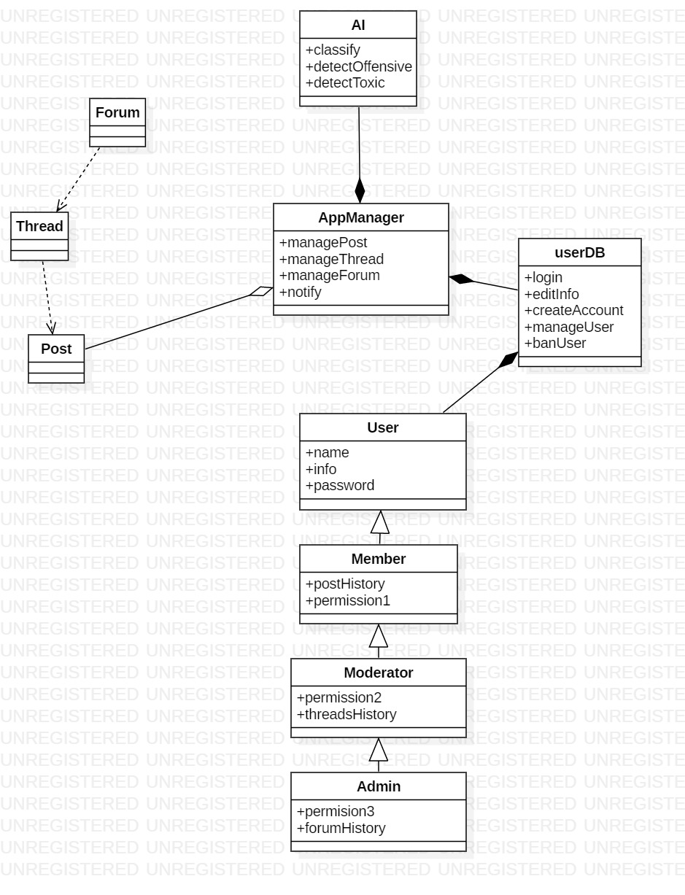

5. SEQUENCE DIAGRAM

